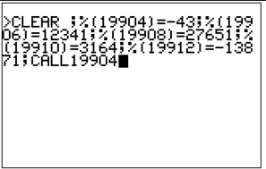**Release software 30**

Well, we sort of have it running BASIC VTL-2 or whatever you want to describe it as. Very shoddily, but it does work.

100 C=30*9

110 B=22*5+3

120 A=C+B

130 G=2173/1000

140 H=%

150 I='

160 J='

170 K='

180 L='

Admittedly you do have to type it into the assembler code directly , well, with a macro anyway, and there’s no output yet – or any of the side effects, or arrays – yet – but it does sort of work and seem to do what it’s supposed to. For information, the ‘ is the random number source and the % is the remainder from the last division.

So, to continue, I have to write the side effects assignments – so writing something like ?=12 prints 12 – and then write the code editor bit.